**WIA2001/WIB2001**

**DATABASE**

**SEM 1, 20116/2017**

**Tutorial 2**

1. Explain the importance of data modelling.
2. What is a business rule? Write possible business rules for class registration.
3. Give an example of each of the three types of relationships.
4. 1:1
5. 1:M
6. M:N
7. Refer to Figure 2.0 below and answer the following questions :

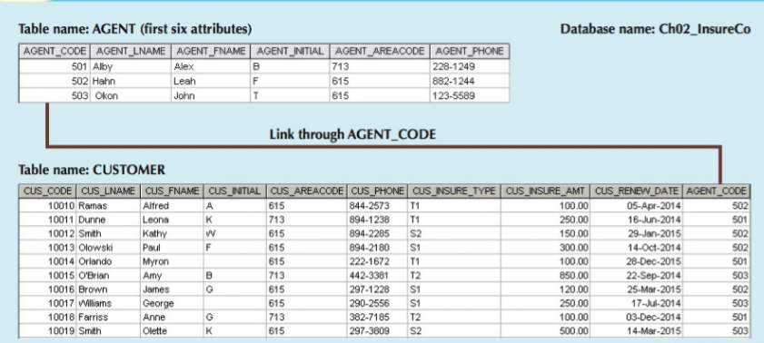

Figure 2.0

1. Write the business rule(s) that governs the relationship between AGENT and CUSTOMER.
2. Given the business rule(s) you wrote in Problem 1, create the basic Crow’s Foot and Chen’s ERD.
3. Draw a Crow’s Foot Notation for the following statements :

The KwikTite Corporation operates many factories. Each factory is located in a region. Each region can be “home” to many of KwikTite’s factories. Each factory employs many employees, but each of those employees is employed by only one factory.

1. What is the difference between a database and a table?
2. Refer to the Figure Q3:11 below and answer the following questions :

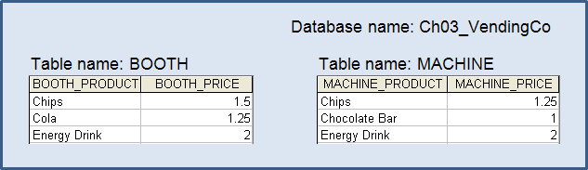

**Figure Q3:11**

1. Create the table that results from applying a UNION relational operator to the tables shown in Figure Q3.11
2. Create the table that results from applying an INTERSECT relational operator to the tables shown in Figure Q3.11.
3. Using the tables in Figure Q3.11, create the table that results from MACHINE DIFFERENCE BOOTH.